11 Importing an assembly

11.1 Procedure -Importing a module
1. on the File tab, select → Import assembly into Teamcenter.
2. Select FFG Engineering Item from the Default Settings group in the Item Type list.
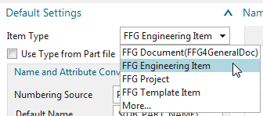
3. In the Components group, select the following:
* Include Component Parts
* Include dependent parts
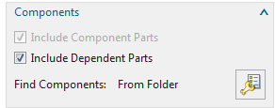
Tip:
If you also import component parts and dependent parts, you must select the Include component parts and Include dependent parts check boxes before you select the assemblies to import.
4. Click Find Components to display the dialog box Load Options for Assemblies.
5. In the Load list, select From Folder.
6. in the Parts to import group, click Import from folder .
7. Navigate to the appropriate directory in which the assembly to be imported is located and select the top element (top assembly node) for this.
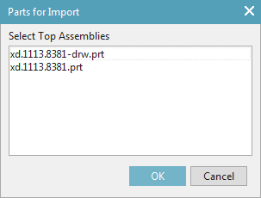
8. Under Default Parameters, in the Default Destination Folder box, type the path or navigate to the folder in Teamcenter where the imported items will be placed. You can manually type a folder that is outside your personal tray in the field, but you must have write permissions to the folder.
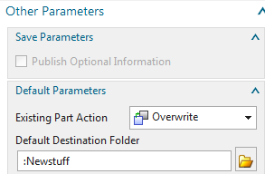
9. Under Default Parameters, click Projects .
10. In the Assign to Project dialog box, select a project, and then click OK.
The list contains the projects that are available in Teamcenter and of which you are a member. You can select one or more projects.
11. Click Test Run to perform a simulated import. When the simulated import process is complete, the Information window displays how the parts and assemblies were imported. In the Information window, check that all information, including import action, naming technique, directory path, etc., is correct.
12. Close the Information window.
13. Make a note of the item ID of the top assembly node.
14. In the Import Assembly to Teamcenter dialog box, click OK to start the import.
15. In the Information window, check whether the import took place as expected.
16. Display the imported items in Teamcenter Navigator.
Note:
The import of an assembly with drawings takes place via the same procedure → the import function recognizes whether a UGPart (drawing) exists for the UGMaster (model). This is automatically linked → the relationship type of the UGMaster is „master“ and the drawing is „specification“.

Caution:
Occasionally it happens that the old document number is stored as ID during the import → This can then be assigned manually according to the prescribed number range. A solution is being worked on.
How the import of assemblies is to be mapped processually with GoLive from Teamcenter still has to be defined. (Keyword: Duplicates).|@red: |

