9 standard and purchased parts

9.1 Basics
The concept of standard and purchased parts provides that a designer can first create such parts himself. When these parts are released, they are „handed over“ to the standards body, i.e. they are assigned to the group (KV) „ST“ and are also marked „Standard part = Yes“ or „Standard part = Yes“.
The actual approver is always the standards body, i.e. a person from the group/role „ST.FFG/Design-Admin“. This person also has the option of editing the part before releasing it, if necessary, or rejecting the release to the initiator.

9.2 Release of standard and purchased parts by the design engineer

9.2.1 Start of the release process
As a designer, you create a part in the familiar way. This part belongs to your current group (KV), e.g. EI.FFG.
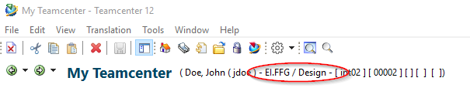
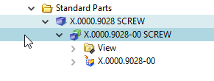
To release a standard or purchased part, select one or more item revisions and press Ctrl+P.
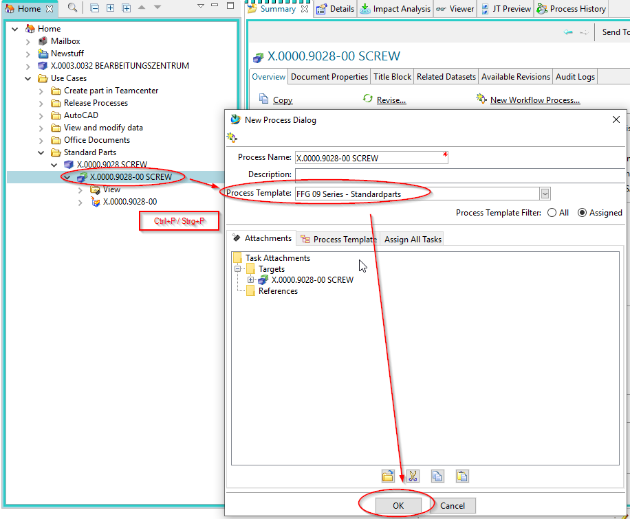
In the following dialog select the workflow „FFG 09 Series - Standard Parts“.
Press „OK“.
You will see the workflow under „Task to Track“ and can follow the process there.
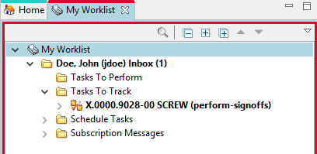
This concludes your work as a designer for the time being.

9.3 Release of standard and purchased parts by the standard authority
All persons of the standards bodies, i.e. with the group/role „ST.FFG/Design-Admin“, receive a release task in their „Worklist“.
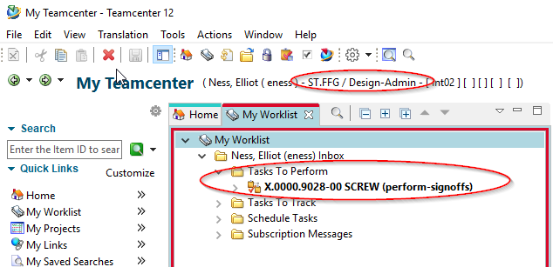
A person in this group/role must now edit this task further.
Select the task and press the „Peform“ button.
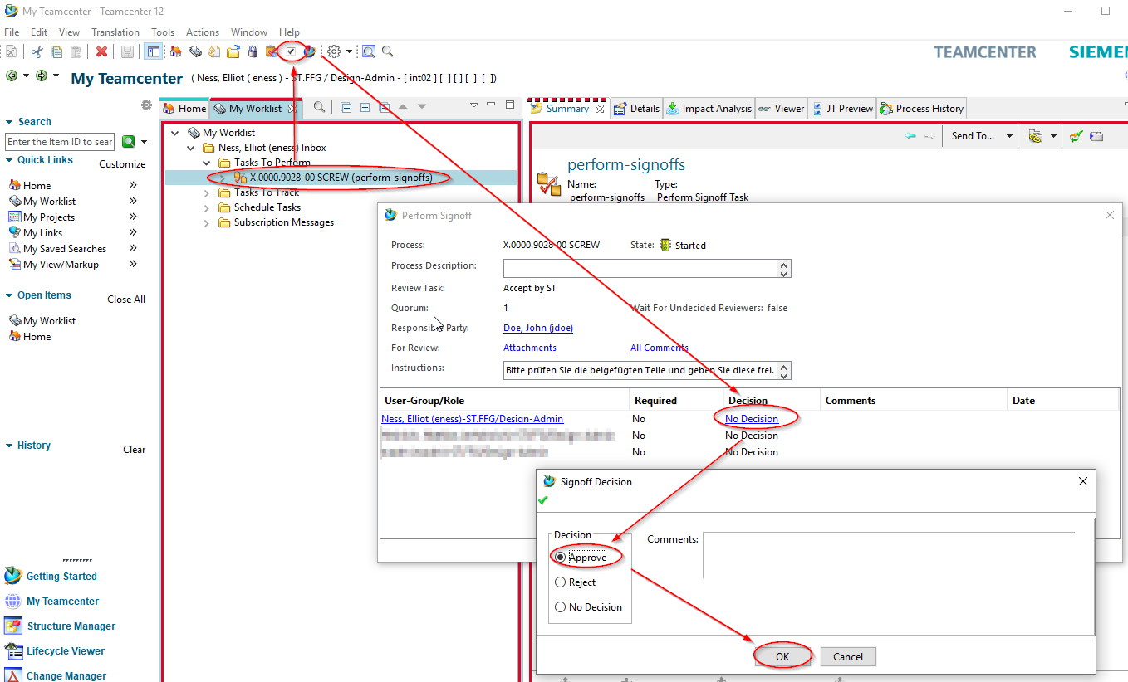
In the following dialog press on the „Decision“ entry in the line with your account.

9.3.1 Release / Approve
Press „Approve“.
Press „OK“.
You have now taken over the further processing of the task.
Note that the part now belongs to the „ST“ group and has been assigned the identifier „Normeil=Yes“ or „Standard Part = Yes“.
In addition, the group (KV) has been given write authorization for the part.
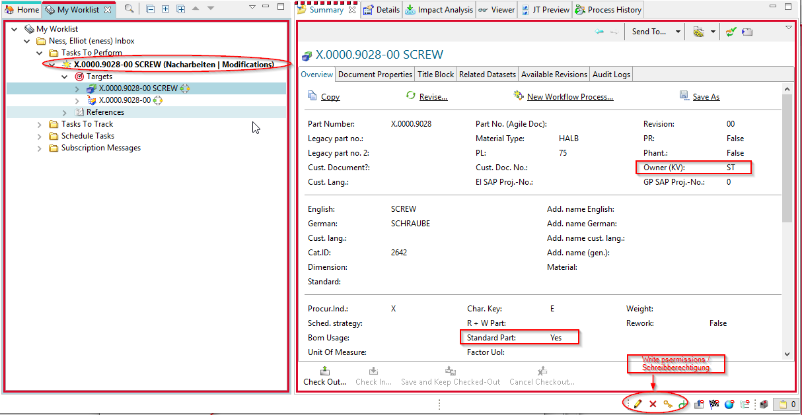
If necessary, make modifications to the revision. You can change the attributes or make constructive changes so that the part corresponds to the specifications of a standard or purchased part.
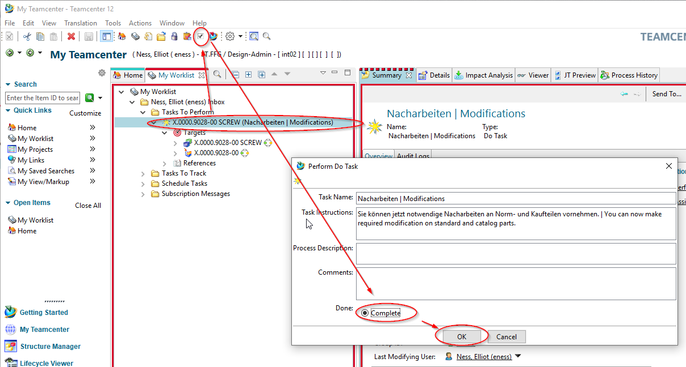
Now select the task in the worklist.
Press the „Perform“ button in the menu bar.
Select „Complete“.
Press „OK“.
If necessary, neutral formats are generated and the parts then receive the status „SE (Series)“.
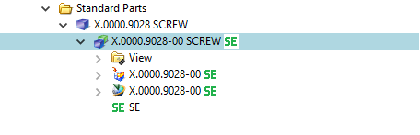

9.3.2 Reject
If release is not possible from the standards body, the workflow can be rejected with the „Reject“ decision to the designer.
Select the task and press the „Perform“ button.
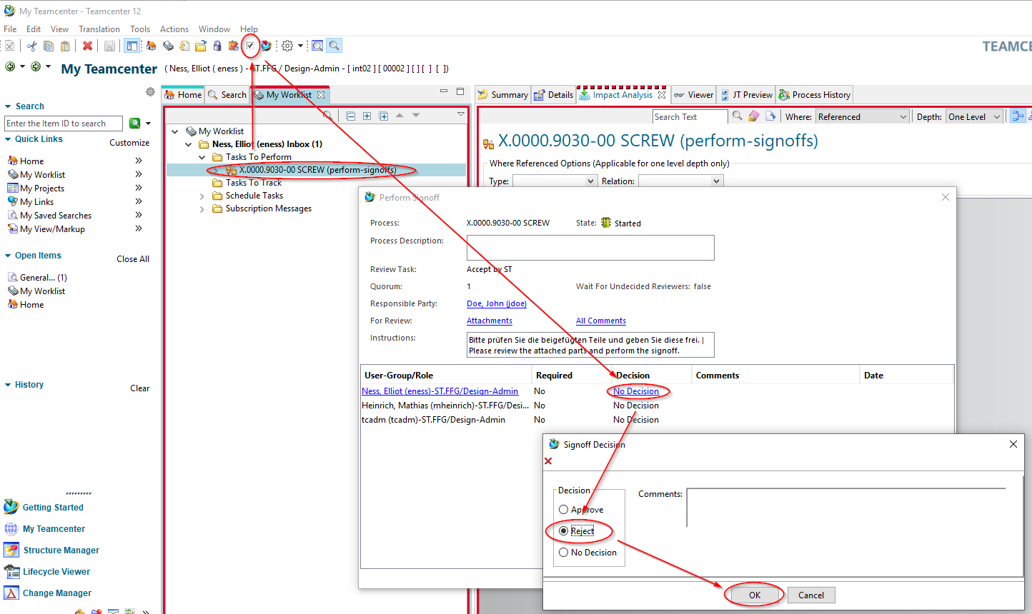
Select „No Decision“ and select „Reject“ in the following dialog.
Press „OK“.
The designer receives a new task in the „Worklist“. Note that you now also have write permissions to the parts in the workflow again.
If necessary, make changes to the parts.
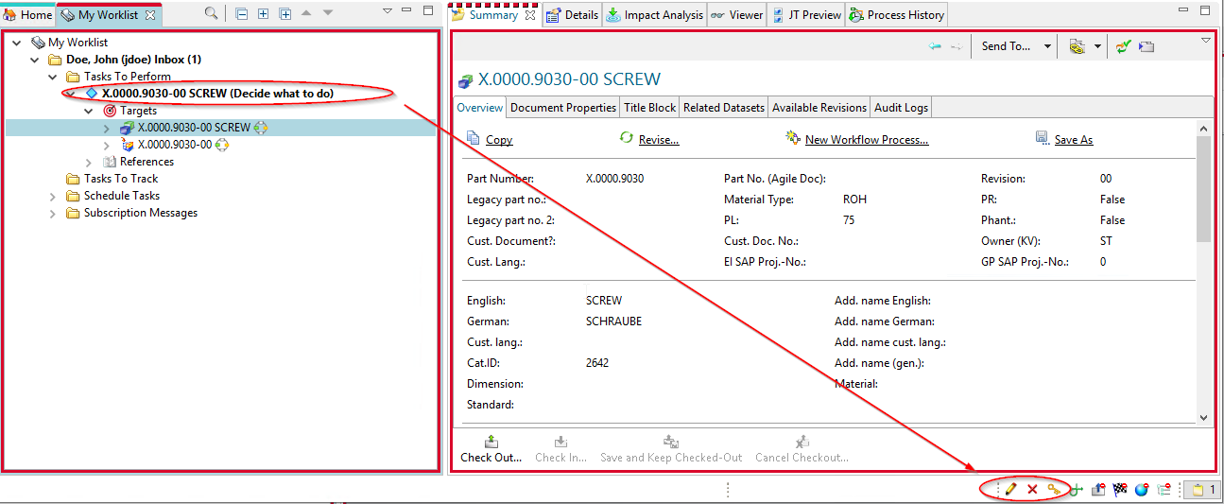
To release the task again, select the task and press the „Perform“ button.
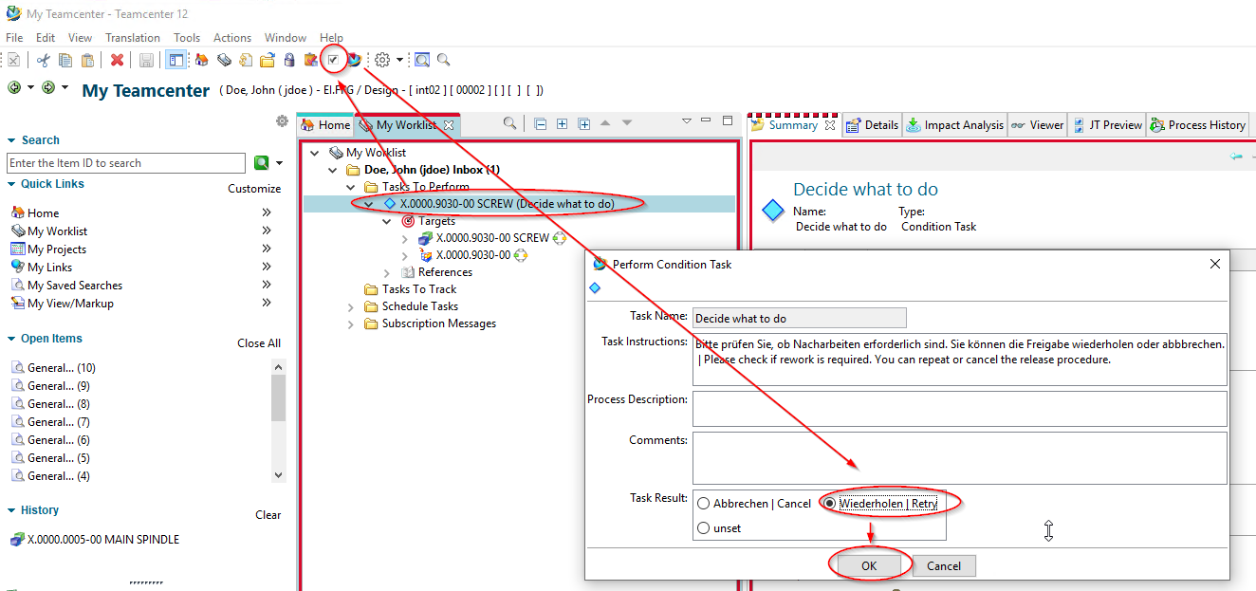
In the following menu, select „Repeat| Retry“.
Press „OK“.
The workflow continues and the persons of the standards authority receive the task again for release in their worklist.
Note: If you select „Cancel | Cancel“, the workflow is terminated in a controlled manner and no release takes place. The part(s) can later be re-set in the release process.

9.4 Release of standard parts and purchased parts the standard position
If standard and purchased parts have been created by the standards body itself, they can be released with a simplified workflow.
The assumption is that when the process is initiated by a person from the standards body, the necessary prerequisites for approval are fulfilled and no further testing or processing is required. Only the technical prerequisites necessary for release are checked, such as mandatory attributes.

